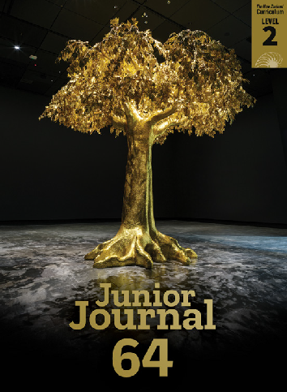
All about Trees
Junior Journal 64
Level 2

All about Trees
The texts in this journal are linked by the topic of trees, providing opportunities for ākonga to think about trees from scientific, cultural, environmental, and artistic perspectives. Having several texts exploring the same topic stimulates curiosity and enables ākonga to build their knowledge over time. Background knowledge, including vocabulary knowledge, contributes to success in reading. In turn, reading success builds knowledge, comprehension, and motivation and strengthens reading behaviours that will support further reading.

There are PDFs of all Junior Journal texts, as well as teacher support material (TSM) and audio

versions for some texts, available at: juniorjournal.tki.org.nz

Junior Journal 64 Contents

What Is a Tree? Gold 1 | TSM Audio Tree Facts Gold 1 | TSM Audio

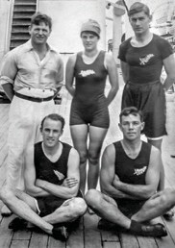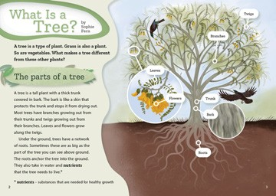A report with information about trees and a simple explanation of photosynthesis and its importance. This text is designed to be used as an introduction to the topic and is accompanied by a detailed TSM. The suggestions in this TSM can be built on when using the other texts, which have shorter TSMs.
OUR FIRST OLYMPIANS
by Bill Nagelkerke

The Summer Olympic Games are held every four years. Countries from all over the world send teams of athletes to take part. In 2016, one hundred and ninety-nine New Zealand athletes went to the Summer Olympics in Brazil. They won eighteen medals, including four gold. For the first time ever, more than half the team was female.
It hasn’t always been like that …

The first New Zealand team
At the 1920 Olympic Games, many things were different. Those games took place in Antwerp, Belgium. Only one of the New Zealand athletes was female (but she was one quarter of the team – we sent only four athletes altogether!).
The members of the New Zealand team were rower Darcy Hadfield, hurdler Harry Wilson, sprinter George Davidson, and swimmer Violet Walrond. Violet was the youngest swimmer at the 1920 Games. She was just fifteen years old.
The team was New Zealand’s first national team. Before 1920, we had either joined with Australia to send a team or we had
not sent anyone at all. Our athletes did well; one of them won a medal, and all four made it into a final.

1920 New Zealand Olympic team with Violet’s father ►
18
Information about five Aotearoa New Zealand
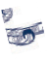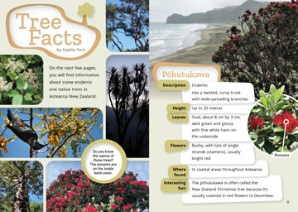trees presented in table form.
Monsters
by Tricia Glensor

Before you go to sleep at night, do you check under the bed for
monsters? If you do, donʼt worry – youʼre not the only one! Afinemata/Gāhehelevao
People everywhere tell stories about monsters. Some monsters Tokelau has stories about a monster called Afinemata or
are huge, scary creatures that roam the countryside. Others lie Gāhehelevao. This monster prowls round the island at night,
in wait in caves or rivers, ready to grab anyone who comes too dragging a long fishing line behind her or carrying a sack. She uses close. And some monsters look frightening but can be caring and these to catch children who misbehave, then carries them off. friendly. Here are some examples. Sometimes, if it’s getting late and their children don’t want to go
to bed, parents might tell a story about her. “Afinemata will be
Kāhui Tipua coming around soon. You’d better be tucked up in bed and
In Aotearoa, there are stories about the Kāhui Tipua – a tribe of fast asleep.” fierce giants. According to these stories, the Kāhui Tipua lived long
ago in the South Island. Some of them Kraken
were so big they could stride from one In Norway and other Scandinavian
mountaintop to another and swallow countries, there are tales about huge
whole streams. They hid in caves and sea creatures called kraken. These
attacked anyone who walked past. monsters are described as being like giant octopuses. Sailors feared kraken because, in the tales, they sometimes attacked and sank passing ships.
2
3

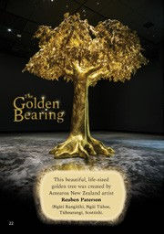The Sticky, Sticky Pine Purple 2 | TSM Audio The Golden Bearing

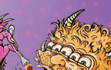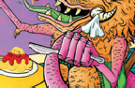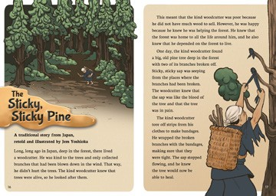A traditional Japanese story with a message about kindness and caring for trees.
My monster’s name is Megabyte, his manners are quite rare.
He has enormous hairy hands,
five bloodshot eyes, ten yellow fangs – but likes to dine with candles and
a table and a chair.

When he gobbles up his dinner, I’m happy to report,
he holds a napkin in his tail
to wipe his tusks and claws and scales, he clears his plate and never fails
to use a knife and fork.

Greg O’Connell
9
A photo of a spectacular artwork by Reuben Paterson to stimulate the imagination.

Trees and Us Purple 2 | TSM Audio Leaf Art
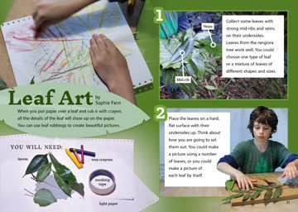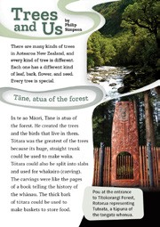A report about how trees are used and valued.
Monsters
by Tricia Glensor

Before you go to sleep at night, do you check under the bed for
monsters? If you do, donʼt worry – youʼre not the only one! Afinemata/Gāhehelevao
People everywhere tell stories about monsters. Some monsters Tokelau has stories about a monster called Afinemata or
are huge, scary creatures that roam the countryside. Others lie Gāhehelevao. This monster prowls round the island at night,
in wait in caves or rivers, ready to grab anyone who comes too dragging a long fishing line behind her or carrying a sack. She uses close. And some monsters look frightening but can be caring and these to catch children who misbehave, then carries them off. friendly. Here are some examples. Sometimes, if it’s getting late and their children don’t want to go
to bed, parents might tell a story about her. “Afinemata will be
Kāhui Tipua coming around soon. You’d better be tucked up in bed and
In Aotearoa, there are stories about the Kāhui Tipua – a tribe of fast asleep.” fierce giants. According to these stories, the Kāhui Tipua lived long
ago in the South Island. Some of them Kraken
were so big they could stride from one In Norway and other Scandinavian
mountaintop to another and swallow countries, there are tales about huge
whole streams. They hid in caves and sea creatures called kraken. These
attacked anyone who walked past. monsters are described as being like giant octopuses. Sailors feared kraken because, in the tales, they sometimes attacked and sank passing ships.
2
3

Instructions for making leaf rubbings.

Related Texts
Non-fiction with information about trees or other plants: “Pōhutukawa” (JJ 45); “Kākano” (a poem) and “Seeds” (JJ 50); “Rongoā Māori” and “Helpful Trees and Plants” (JJ 49); “Dig In!” (JJ 52); “Weaving Tukutuku” (JJ 55)
Non-fiction with links to environmental issues: Too Many Possums (RTR Purple); “Catching Mustelids”, “A New Home for Mokomoko” (JJ 43); “Energy from the Sun” (JJ 57); “Bird of the Year” (JJ 59); “Volunteers” (JJ 63)
Texts with information presented in tables or diagrams: Wheels and Will They Float? (RTR shared); “And the Winner Is” (JJ 59); “Bringing Back the Birdsong” (Taking Action, Connected L2, 2017); “The Takeaway Table” (I Spy, Connected L2, 2013)
Activities: “Pine Cone Pals” (JJ 36); “Fold a Flower” (JJ 37)
Fiction about trees or with bush settings: How Kiwi Saved the Forest (RTR shared); Did You Shake Your Tail Feathers? (RTR Purple); “Autumn Leaves”
(a poem, JJ 36); “Professor Clever” (a play) and “Rātā me te Rākau” (JJ 57)
Traditional stories: Jack and the Beanstalk (RTR shared); Monkey and Crocodile (RTR Turquoise); Two Tiger Tales (RTR Purple); “Chang-O and the Moon”, “Rumpelstiltskin” (JJ 56); “Rātā me te Rākau” (JJ 57); “Rua and Te Manu” (JJ 61)

ISBN 978-1-77690-897-4 (pdf)
ISBN 978-1-77690-898-1 (word)
TEACHER SUPPORT MATERIAL FOR “ALL ABOUT TREES”, JUNIOR JOURNAL 64, 2022 1
Copyright © Crown 2022
Accessed from www.juniorjournal.tki.org.nz

